

4-H MEMBER RECORD BOOK

Name ____ ___ ____ ___ ___ ___ ____

Club __ __ ___ ___ ___ ___ ___ ____

**4-H Member Record Book Instructions**

Assemble your book per the order listed below. You may handwrite or type the information. Please limit additional items like pictures to one per project area. Ribbons should not be included. If the form isn’t big enough to handle your activities, please include extra copies of the page to accommodate the extra content.

#### Kalamazoo County 4-H Member Award Application

*Section 1 – Introduction*

Title Page

*Section 2 – Participation and Activities*

4-H Participation Summary 4-H Participation Details

4-H Award Recognition 4-H Promotion Activities Outside of 4-H

*Section 3 – 4-H Projects*

4-H Project Summary

4-H Project Record Forms

Include a completed 4-H Project Record Form for each project completed each year. This information is especially helpful to judges when reviewing applications for project specific awards like County Medals and the Kalamazoo County Farm Bureau Project Awards.

*Section 4 – My 4-H Story*

Here is your chance to help the judges understand who you are, how 4-H has impacted you and why you should be chosen for awards you’re applying for.

*Section 5 - Supplemental Award Applications*

If applying for the Key Club Award, be sure to include the supplemental application as section 5. The application is located at: <https://www.canr.msu.edu/uploads/files/Application.pdf>

### Section 1, Title Page

Get creative and help the judges get to know you. Include your name, age, community club and picture (optional).

Name: Age (as of January 1 this year):

Club:

### Section 2, 4-H Participation Summary

Community Club:

|  |  |  |  |  |  |
| --- | --- | --- | --- | --- | --- |
| Year | 4-H  Age | Grade | Years in 4-H (including this year) | Number of Club Meetings Held | Number of Club Meetings I Attended |
| 20 - 20 | 8 |  |  |  |  |
| 20 - 20 | 9 |  |  |  |  |
| 20 - 20 | 10 |  |  |  |  |
| 20 - 20 | 11 |  |  |  |  |
| 20 - 20 | 12 |  |  |  |  |
| 20 - 20 | 13 |  |  |  |  |
| 20 - 20 | 14 |  |  |  |  |
| 20 - 20 | 15 |  |  |  |  |
| 20 - 20 | 16 |  |  |  |  |
| 20 - 20 | 17 |  |  |  |  |
| 20 - 20 | 18 |  |  |  |  |
| 20 - 20 | 19 |  |  |  |  |

### Section 2, 4-H Participation Details

Beyond project areas, how have you been involved in 4-H? How have you helped others learn about the program and its benefits? Include activities like participation in club activities, committees, refreshments, leading or participating in community service projects, working in the food booth, fund raiser, fair activities, club offices held and others. The first entry is included as an example.

|  |  |  |
| --- | --- | --- |
| Year | Event or Activity | Describe Your Involvement (include audience # if appropriate) |
| 2022 | Still project monitoring at fair | Answer questions from community members who are viewing still projects |
|  |  |  |
|  |  |  |
|  |  |  |
|  |  |  |
|  |  |  |
|  |  |  |
|  |  |  |
|  |  |  |
|  |  |  |
|  |  |  |
|  |  |  |
|  |  |  |
|  |  |  |
|  |  |  |
|  |  |  |
|  |  |  |
|  |  |  |
|  |  |  |
|  |  |  |
|  |  |  |

### Section 2, 4-H Award Recognition

List any 4-H awards you have received including trips, County Medals, club awards, etc. Be sure to include County Medals and Kalamazoo County Farm Bureau Project Awards you’ve received. Do not include placings from fair like Best of Show, 3rd place or A ratings.

|  |  |
| --- | --- |
| Year | Award |
|  |  |
|  |  |
|  |  |
|  |  |
|  |  |
|  |  |
|  |  |
|  |  |
|  |  |
|  |  |
|  |  |
|  |  |
|  |  |
|  |  |
|  |  |
|  |  |
|  |  |
|  |  |
|  |  |
|  |  |
|  |  |
|  |  |
|  |  |
|  |  |
|  |  |
|  |  |

### Section 2, 4-H Promotion

List any 4-H promotional opportunities such as a talk, demonstration, working exhibits, newspaper interviews, etc.

|  |  |  |  |  |
| --- | --- | --- | --- | --- |
| Year | Type of Promotion | Topic | 4-H Project Area (if applicable) | Location & Number of Attendees (if applicable) |
|  |  |  |  |  |
|  |  |  |  |  |
|  |  |  |  |  |
|  |  |  |  |  |
|  |  |  |  |  |
|  |  |  |  |  |
|  |  |  |  |  |
|  |  |  |  |  |
|  |  |  |  |  |
|  |  |  |  |  |
|  |  |  |  |  |
|  |  |  |  |  |
|  |  |  |  |  |
|  |  |  |  |  |
|  |  |  |  |  |
|  |  |  |  |  |
|  |  |  |  |  |
|  |  |  |  |  |
|  |  |  |  |  |
|  |  |  |  |  |
|  |  |  |  |  |
|  |  |  |  |  |
|  |  |  |  |  |

## Section 2, Activities Outside of 4-H

What you learn in 4-H can be applied to things you do in your home, school, and community. Summarize your involvement in activities outside of 4-H such as athletics, other organizations, and home responsibilities (**be specific** such as fix evening meal during summers, mow lawn, etc.). Report participation, leadership roles, and recognition. We provided an example.

|  |  |  |
| --- | --- | --- |
| Year | Activities in Your Home and with Family | Activities in your Community & School |
| 2020 | Babysitting my brother and sister, making dinner every Thursday night | Member of Boy Scouts, library assistant, football team captain |
|  |  |  |
|  |  |  |
|  |  |  |
|  |  |  |
|  |  |  |
|  |  |  |
|  |  |  |
|  |  |  |
|  |  |  |
|  |  |  |
|  |  |  |
|  |  |  |
|  |  |  |
|  |  |  |
|  |  |  |

## Section 3, 4-H Project Summary

What project areas did you participate in each year? List the project areas in the first column and use an X to indicate what years you participated in that project. The first row was completed as an example. Remember to complete a 4-H Project Record Form for each award project area.

|  |  |  |  |  |  |  |  |  |  |  |  |  |
| --- | --- | --- | --- | --- | --- | --- | --- | --- | --- | --- | --- | --- |
|  | 20 -  20 | 20 -  20 | 20 -  20 | 20 -  20 | 20 -  20 | 20 -  20 | 20 -  20 | 20 -  20 | 20 -  20 | 20 -  20 | 20 -  20 | 20 -  20 |
| Fine Art |  | X |  | X | X | X |  |  |  |  |  |  |
|  |  |  |  |  |  |  |  |  |  |  |  |  |
|  |  |  |  |  |  |  |  |  |  |  |  |  |
|  |  |  |  |  |  |  |  |  |  |  |  |  |
|  |  |  |  |  |  |  |  |  |  |  |  |  |
|  |  |  |  |  |  |  |  |  |  |  |  |  |
|  |  |  |  |  |  |  |  |  |  |  |  |  |
|  |  |  |  |  |  |  |  |  |  |  |  |  |
|  |  |  |  |  |  |  |  |  |  |  |  |  |
|  |  |  |  |  |  |  |  |  |  |  |  |  |
|  |  |  |  |  |  |  |  |  |  |  |  |  |
|  |  |  |  |  |  |  |  |  |  |  |  |  |
|  |  |  |  |  |  |  |  |  |  |  |  |  |
|  |  |  |  |  |  |  |  |  |  |  |  |  |
|  |  |  |  |  |  |  |  |  |  |  |  |  |
|  |  |  |  |  |  |  |  |  |  |  |  |  |
|  |  |  |  |  |  |  |  |  |  |  |  |  |
|  |  |  |  |  |  |  |  |  |  |  |  |  |
|  |  |  |  |  |  |  |  |  |  |  |  |  |

## Section 3, 4-H Project Record Form

Project Area

This is my year in 4-H and year in the project.

#### Complete a new 4-H Project Record Form for each project, each year.

By keeping 4-H records you can:

* Learn how to set goals, record what you do and learn, and evaluate.
* Feel good about your 4-H experience.
* Learn how to share information with others.
* Learn how to be more organized.
* Learn responsibility by getting the job done.

***Goals*** - Goals are like a road map, they help you decide how you get to where you want to go.

#### My goal is to:

**I plan to reach this goal by:**

**What do you like best about participating in this project?**

**What would you change or do differently next time? What would you like to learn to impact your participation in the project next year?**

***Project Knowledge – (****This section is to be completed after the project is complete/after fair.)*

#### Describe two things you have learned while doing this project. Be Specific.

**List awards, placings, ribbons and recognition earned in this project area this year.**

***Life Skills*** (*This section applies only to 4-H members 12-19 years old)*

#### Choose two life skills from the diagram attached and describe how you have developed each of the life skills through your 4-H project.

**How have those life skills helped you outside of 4-H?**

**4-H Life Skills**

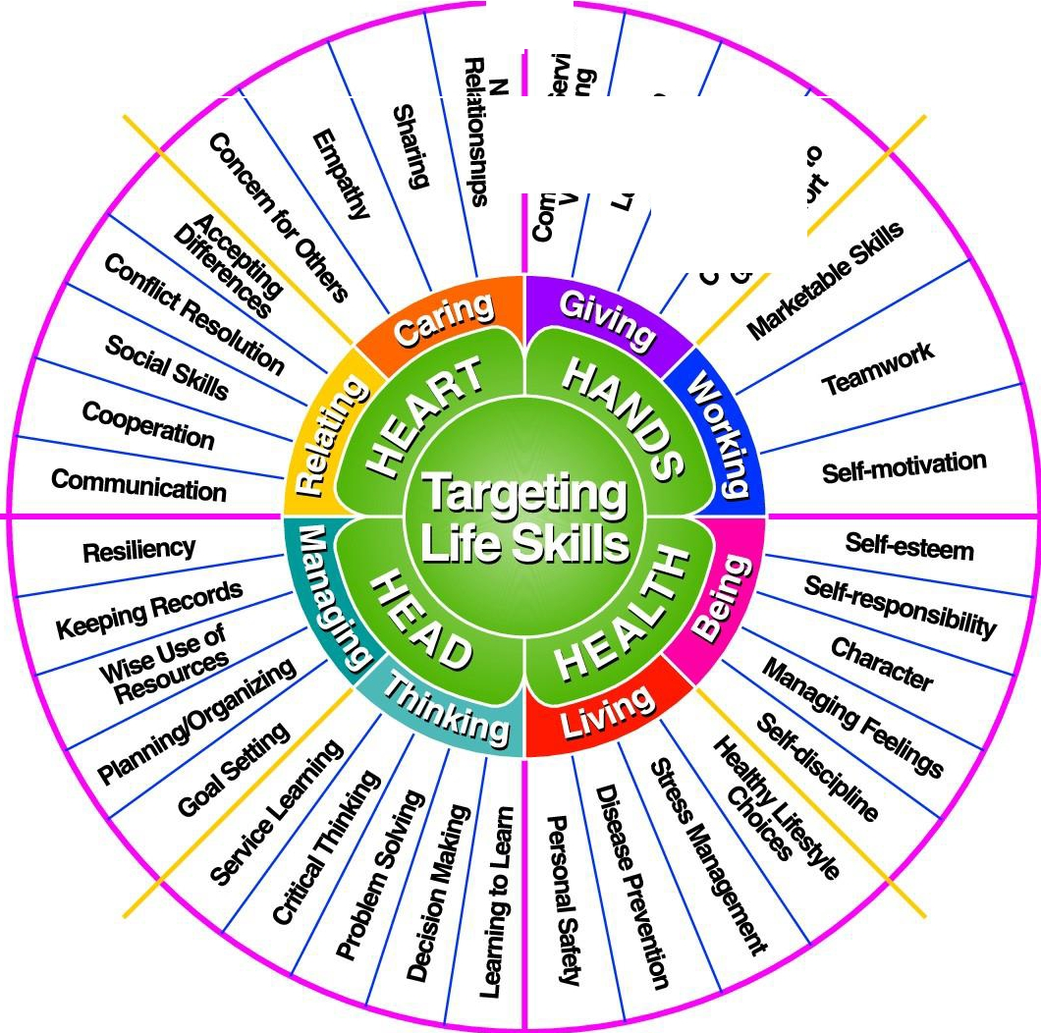

**.3**

**z**

•

* ***-1$***

*CJ (/)*

•

# Iowa State University "Targeting Life Skills Model"

Patricia Hendricks, November 1996

## Section 4, My 4-H Story

Please help the judges understand who you are and why you should receive the awards you’re applying for. Consider covering the following topic areas:

* What do you like most about being a 4-H member? You may want to include the good times, the fun times, what you have gained by meeting and working with other 4-H youth and adults.
* What do you want to accomplish in 4-H in the future?
* How is 4-H going to help you achieve goals?
* Why are you applying for these awards?
* *I Dare You* and Key Club Award applicants - Describe how you have used and displayed your leadership skills in 4-H and your community.